
AstraQuantum Tech
Week 3 - Static Routing & Network Traffic Analysis
Three-Router Enterprise Network Lab - Cisco Packet Tracer
Student Name | Muhammad Raza
Program | AstraQuantum Tech — Summer of Cybersecurity 2026
Assessment Name | Static Routing & Network Traffic Analysis
Week | Week 3
Submission Date | August 26, 2026

Table of Contents
1. Cover Page 1
2. Lab Objectives 3
3. Network Topology 3
4. IP Addressing 4
5. Router Configuration 5
6. Connectivity Testing 7
7. Traffic Analysis 10
8. Troubleshooting 11
9. Online Labs 14
10. Questions 17
11. Reflection 20

2. Lab Objectives
This lab was designed to teach the fundamentals of building and troubleshooting a small routed enterprise network. Specifically, it aimed to build practical skill in: configuring a three-router topology in Cisco Packet Tracer with correctly addressed LAN and WAN interfaces; implementing static routing so that three separate LANs can reach one another; verifying connectivity using ping, traceroute, and routing-table inspection; analyzing ARP, ICMP, and TCP/UDP traffic at the packet level using Packet Tracer's Simulation Mode; diagnosing and resolving an intentionally introduced network failure; and reinforcing how this foundational networking knowledge underpins cybersecurity monitoring and defense.

3. Network Topology
The lab topology consists of three routers (R1, R2, R3) connected in a linear chain, each serving its own LAN through an access switch and PC. R1 connects to R2 over a point-to-point WAN link (10.0.12.0/30), and R2 connects to R3 over a second point-to-point WAN link (10.0.23.0/30). Each router's LAN-facing interface connects to a Cisco 2960-24TT switch (SW1, SW2, SW3), which in turn connects to a single end-device PC (PC1, PC2, PC3).
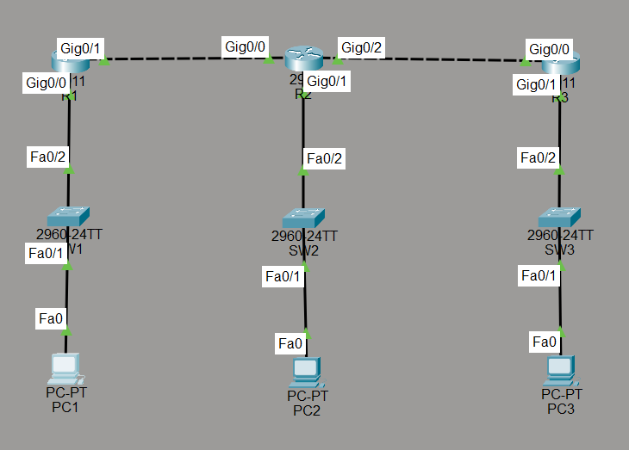
Figure 1 — Final network topology: R1–R2–R3 linear chain, each router serving its own switched LAN and PC.

4. IP Addressing
The addressing plan uses /24 subnets for the three LANs and /30 subnets for the two point-to-point router links, minimizing wasted addresses on the WAN segments.
Device | Interface | IP Address | Subnet Mask | Description
R1 | GigabitEthernet0/0 | 192.168.10.1 | 255.255.255.0 | LAN 1 (PC1)
R1 | GigabitEthernet0/1 | 10.0.12.1 | 255.255.255.252 | WAN link to R2
R2 | GigabitEthernet0/0 | 10.0.12.2 | 255.255.255.252 | WAN link to R1
R2 | GigabitEthernet0/1 | 192.168.20.1 | 255.255.255.0 | LAN 2 (PC2)
R2 | GigabitEthernet0/2 | 10.0.23.1 | 255.255.255.252 | WAN link to R3
R3 | GigabitEthernet0/0 | 10.0.23.2 | 255.255.255.252 | WAN link to R2
R3 | GigabitEthernet0/1 | 192.168.30.1 | 255.255.255.0 | LAN 3 (PC3)
PC1 | FastEthernet0 | 192.168.10.10 | 255.255.255.0 | GW 192.168.10.1
PC2 | FastEthernet0 | 192.168.20.10 | 255.255.255.0 | GW 192.168.20.1
PC3 | FastEthernet0 | 192.168.30.10 | 255.255.255.0 | GW 192.168.30.1

5. Router Configuration
Each router was configured with a hostname, its interface IP addresses, and static routes pointing to the two remote LANs it does not directly serve. Configuration was saved to NVRAM with copy running-config startup-config.

R1 Configuration
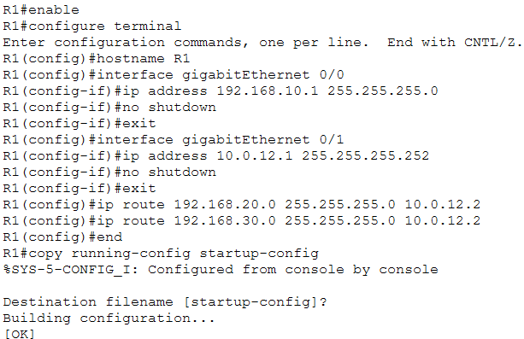
Figure 2 — R1: hostname, Gig0/0 (192.168.10.1/24 LAN) and Gig0/1 (10.0.12.1/30 WAN) addressed, static routes to 192.168.20.0/24 and 192.168.30.0/24 via 10.0.12.2 (R2).

R2 Configuration
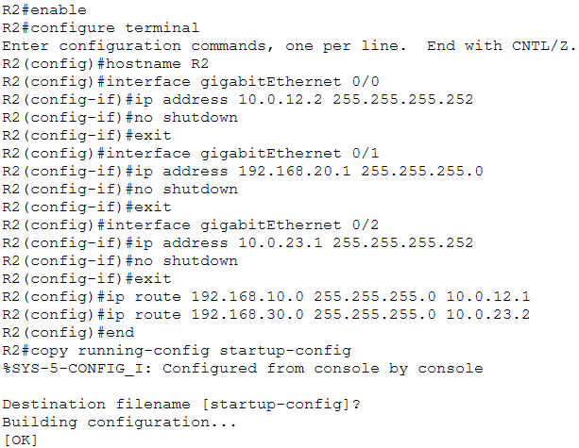
Figure 3 — R2: hostname, Gig0/0 (10.0.12.2/30), Gig0/1 (192.168.20.1/24 LAN) and Gig0/2 (10.0.23.1/30) addressed, static routes to 192.168.10.0/24 via 10.0.12.1 (R1) and 192.168.30.0/24 via 10.0.23.2 (R3).

R3 Configuration
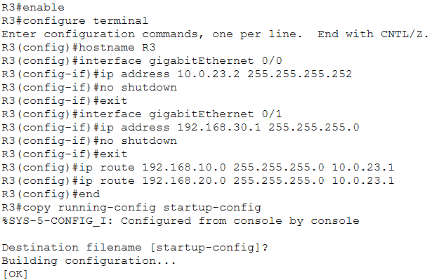
Figure 4 — R3: hostname, Gig0/0 (10.0.23.2/30) and Gig0/1 (192.168.30.1/24 LAN) addressed, static routes to 192.168.10.0/24 and 192.168.20.0/24 via 10.0.23.1 (R2).

PC IP Configuration
Each PC was assigned a static IP address, subnet mask, and default gateway matching its local router interface.
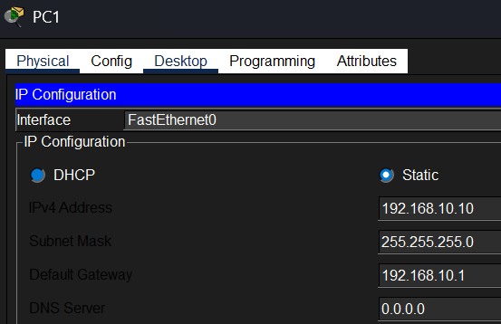
Figure 5 — PC1: 192.168.10.10 / 255.255.255.0, gateway 192.168.10.1.
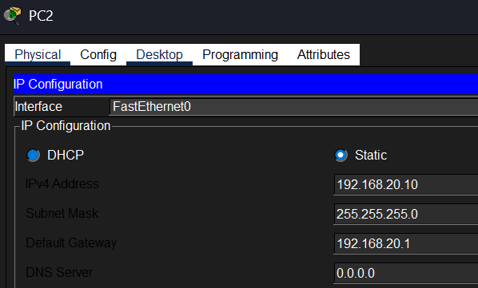
Figure 6 — PC2: 192.168.20.10 / 255.255.255.0, gateway 192.168.20.1.
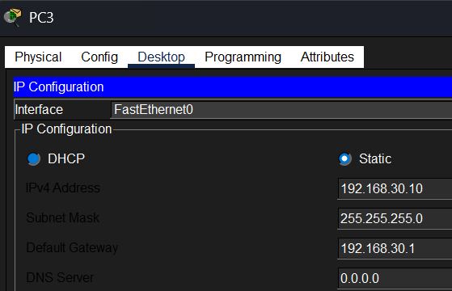
Figure 7 — PC3: 192.168.30.10 / 255.255.255.0, gateway 192.168.30.1.

Interface Verification (show ip interface brief)
After configuration, each router's interfaces were verified as up/up to confirm Layer 1/2 connectivity and correct addressing before testing routing.
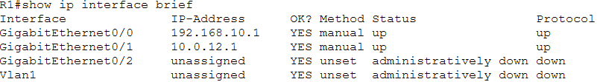
Figure 8 — R1: Gig0/0 192.168.10.1 up/up, Gig0/1 10.0.12.1 up/up.
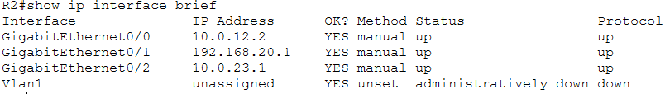
Figure 9 — R2: Gig0/0 10.0.12.2 up/up, Gig0/1 192.168.20.1 up/up, Gig0/2 10.0.23.1 up/up.
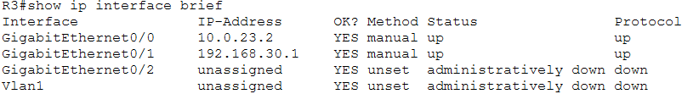
Figure 10 — R3: Gig0/0 10.0.23.2 up/up, Gig0/1 192.168.30.1 up/up.

6. Connectivity Testing

Ping Results
PC1 was used to ping PC3 (192.168.30.10) across all three hops. The first attempt showed partial timeouts while ARP resolved the path; the second attempt succeeded completely with 0% packet loss, confirming full end-to-end reachability.
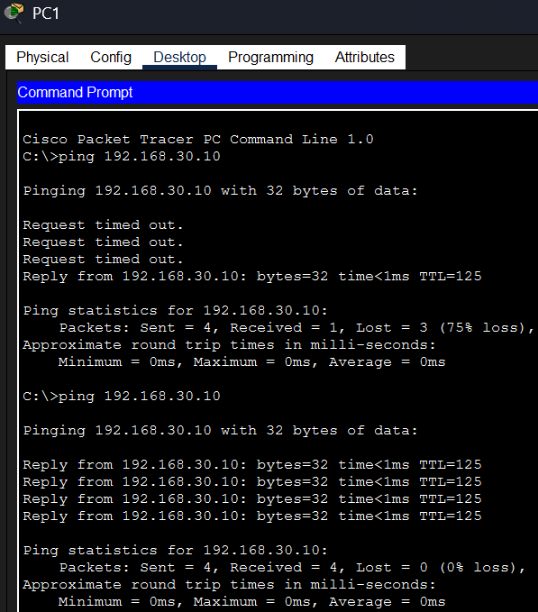
Figure 11 — PC1 → 192.168.30.10: first attempt 3 timeouts + 1 reply (ARP resolving), second attempt 4/4 replies, 0% loss, TTL=125.

Traceroute
A traceroute from PC1 to PC3 confirms the exact hop-by-hop path the packet takes through the network.
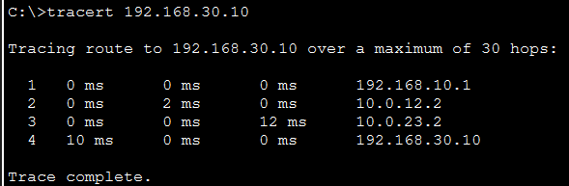
Figure 12 — tracert 192.168.30.10 from PC1: hop 1 = 192.168.10.1 (R1), hop 2 = 10.0.12.2 (R2), hop 3 = 10.0.23.2 (R3), hop 4 = 192.168.30.10 (PC3).

Routing-Table Verification (show ip route)
Each router's routing table was checked to confirm both directly connected networks and the manually configured static routes ('S' entries) to the two remote LANs.
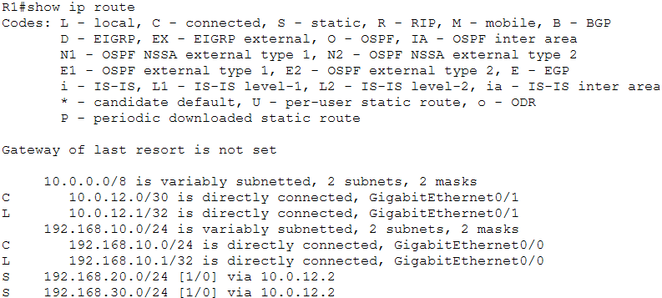
Figure 13 — R1 routing table: connected 10.0.12.0/30 and 192.168.10.0/24; static routes to 192.168.20.0/24 and 192.168.30.0/24 via 10.0.12.2.
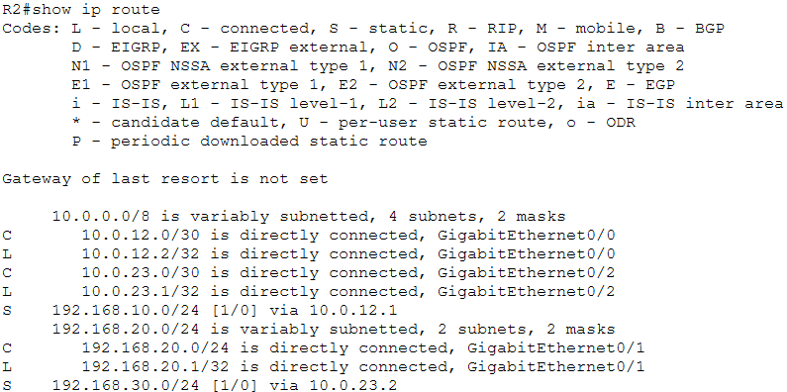
Figure 14 — R2 routing table: connected 10.0.12.0/30, 10.0.23.0/30, and 192.168.20.0/24; static routes to 192.168.10.0/24 via 10.0.12.1 and 192.168.30.0/24 via 10.0.23.2.
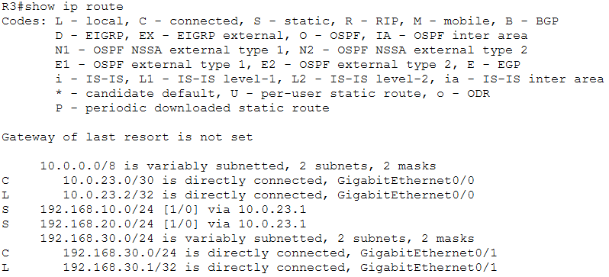
Figure 15 — R3 routing table: connected 10.0.23.0/30 and 192.168.30.0/24; static routes to 192.168.10.0/24 and 192.168.20.0/24 via 10.0.23.1.

7. Traffic Analysis
Packet Tracer's Simulation Mode was used, filtered to ARP and ICMP, to step through an ICMP echo request/reply between PC1 and PC3 one hop at a time and inspect the Layer 2 and Layer 3 header details at each device.
Figure 16 — PDU Information at PC3 (OSI Model view)
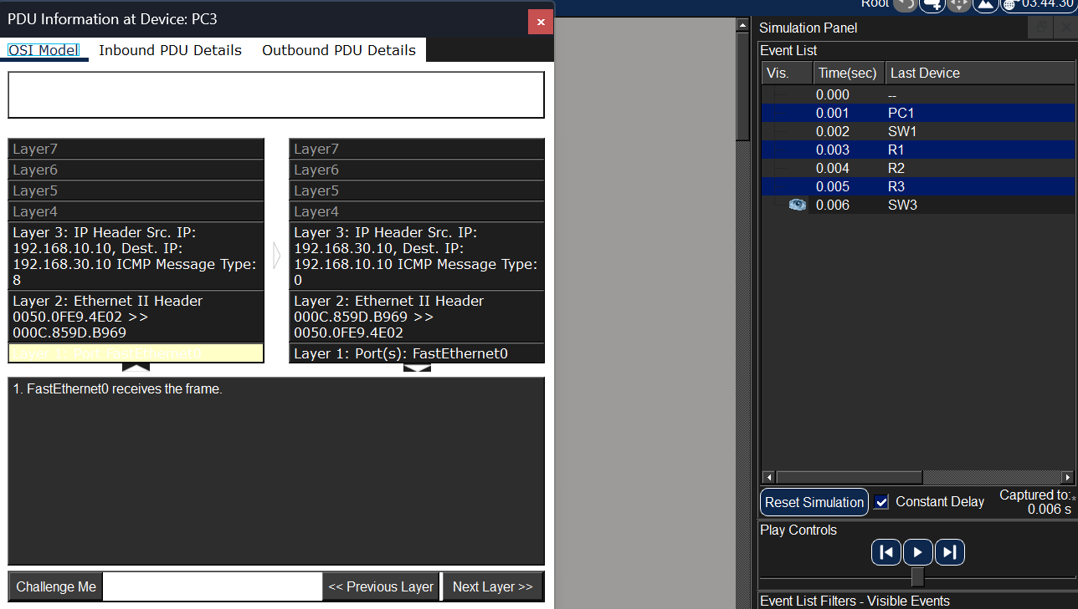
This capture shows the ICMP echo request arriving at PC3. The Layer 3 IP header shows source 192.168.10.10 (PC1) and destination 192.168.30.10 (PC3), ICMP Type 8 (Echo Request) — both addresses stay constant end-to-end across all three hops. The Layer 2 Ethernet II header, by contrast, is local to the final hop: the inbound frame's source/destination MAC pair belongs to R3's outgoing interface and PC3's NIC, not PC1's original MAC. This directly demonstrates that IP addressing is used for end-to-end logical delivery, while MAC addressing is rewritten by each router for delivery across only the immediate physical segment.

ARP Observations
Because 192.168.30.10 is outside PC1's local subnet, PC1 first generates an ARP request to learn the MAC address of its default gateway (R1) rather than the final destination. This ARP request is a Layer 2 broadcast (FF:FF:FF:FF:FF:FF) seen by every device on LAN 1, but only R1 replies. The resulting Ethernet frame carrying the ICMP request out of PC1 is therefore addressed to R1's MAC — PC3's MAC never appears in PC1's original frame, and the frame itself never leaves LAN 1: at R1 the frame is stripped, the IP packet inside is routed, and a brand-new frame is built for the R1–R2 link, and so on at each subsequent hop.

ICMP Observations
The ICMP echo request/reply exchange between PC1 and PC3 confirms reachability across the routed path. The source and destination IP addresses (192.168.10.10 and 192.168.30.10) remain unchanged at every hop, while the Time To Live (TTL) value decrements by 1 at each router — a mechanism that prevents packets from looping indefinitely if a routing misconfiguration exists.

TCP/UDP Observations
This lab's traffic was ICMP- and ARP-based rather than application traffic, so no TCP or UDP segments were directly captured. Conceptually, TCP is connection-oriented and reliable — it establishes a session via a three-way handshake and guarantees delivery and ordering, which suits activities like file transfer or a login (e.g. the Pickle Rick web login in Section 9). UDP is connectionless and does not guarantee delivery, trading reliability for speed and lower overhead, which suits real-time traffic such as DNS lookups or video/voice streams.

8. Troubleshooting
A network failure was intentionally introduced on R2 by removing one of its two static routes, then diagnosed and resolved using the standard Problem / Evidence / Diagnosis / Solution / Verification structure.
Problem
PC1 is unable to communicate with PC3 (192.168.30.10).
How the failure was introduced
On R2: enable → configure terminal → no ip route 192.168.30.0 255.255.255.0 10.0.23.2, deliberately deleting the static route to R3's LAN.
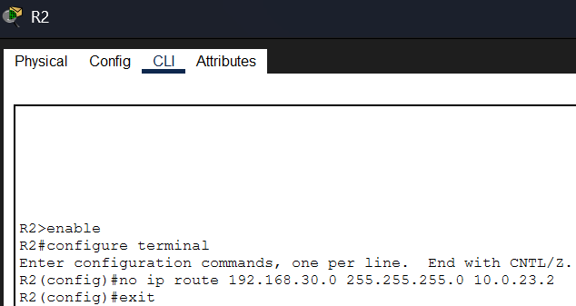
Figure 17 — R2 CLI removing the static route to 192.168.30.0/24.
Evidence
Pinging 192.168.30.10 from a PC now fails, returning "Destination host unreachable" for all 4 packets (100% loss).
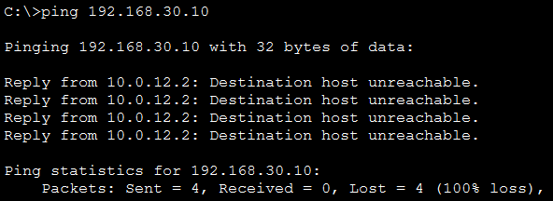
Figure 18 — Failed ping to 192.168.30.10 after the route was removed.

Diagnosis
Running show ip route on R2 confirms the 192.168.30.0/24 entry is missing — only the directly connected 10.0.12.0/30, 10.0.23.0/30, and 192.168.20.0/24 networks remain. Without a routing table entry, R2 has no way to forward packets destined for R3's LAN and drops them.
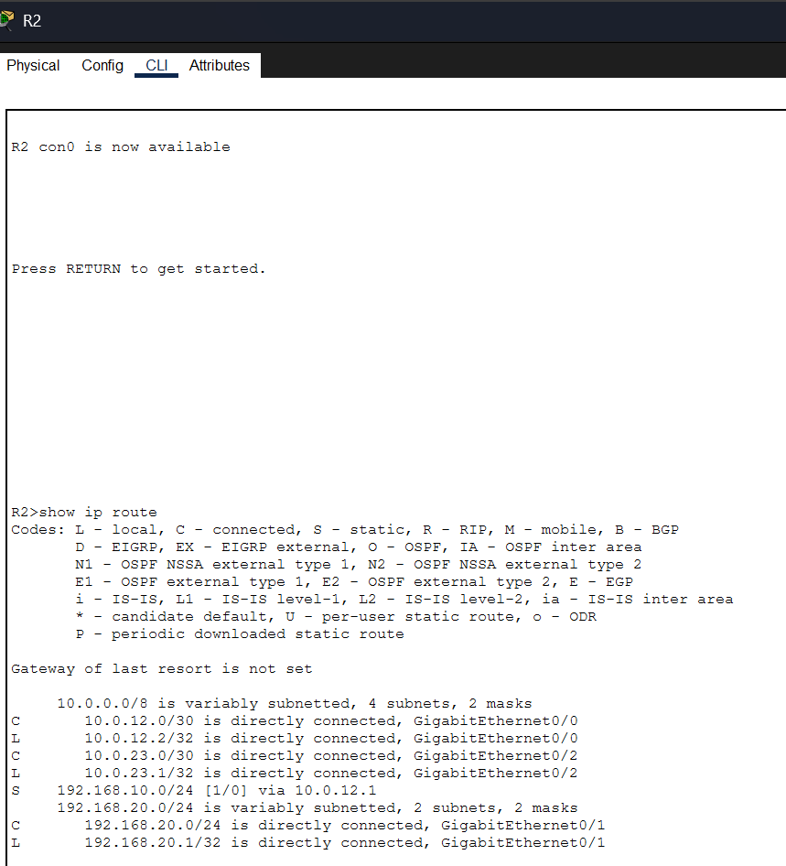
Figure 19 — R2 show ip route after removal: the 192.168.30.0/24 static route no longer appears.
Solution
The missing static route was re-added on R2 in global configuration mode: ip route 192.168.30.0 255.255.255.0 10.0.23.2.
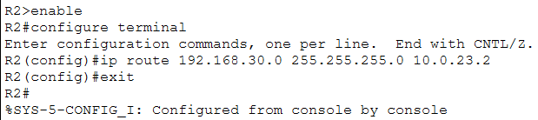
Figure 20 — R2 CLI re-adding the static route to 192.168.30.0/24.

Verification
Pinging 192.168.30.10 from PC1 again succeeds completely — 4/4 replies, 0% loss, TTL=125 — confirming connectivity was fully restored.
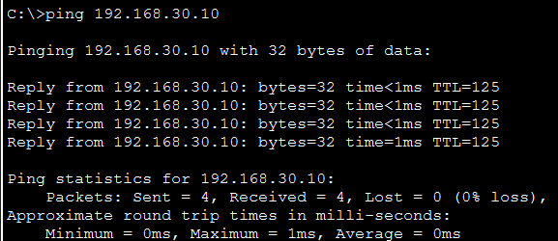
Figure 21 — PC1 → 192.168.30.10 succeeding again after the route was restored.

9. Online Labs
Completion evidence for each required platform room:
Lab | Platform | Status | Evidence
Network Packet Analysis | LetsDefend | Completed | r_1.png
Network Services | TryHackMe | Completed | r_2.png
Network Services 2 | TryHackMe | Completed | r_3.png
DNS in Detail | TryHackMe | Completed | r_4.png
Network Security Essentials | TryHackMe | Completed | r_5.png
Pickle Rick | TryHackMe | Completed | r_6.png

Evidence Screenshots
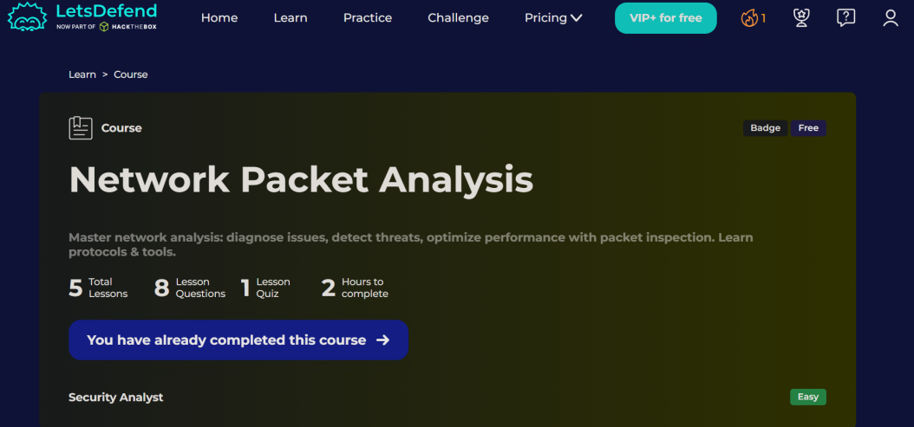
Figure 22 — LetsDefend — Network Packet Analysis course, marked completed.
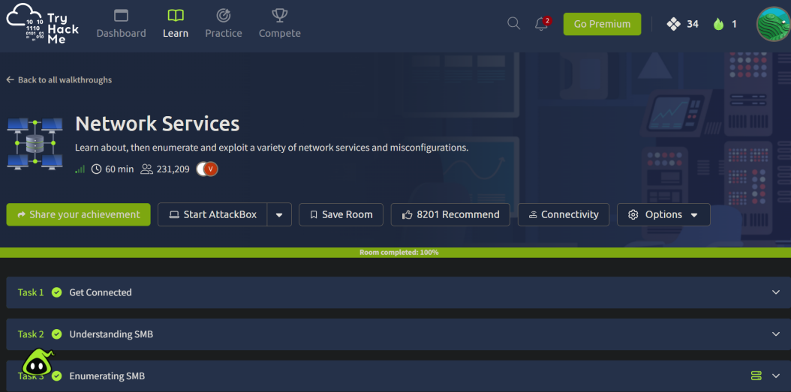
Figure 23 — TryHackMe — Network Services room, 100% completed.
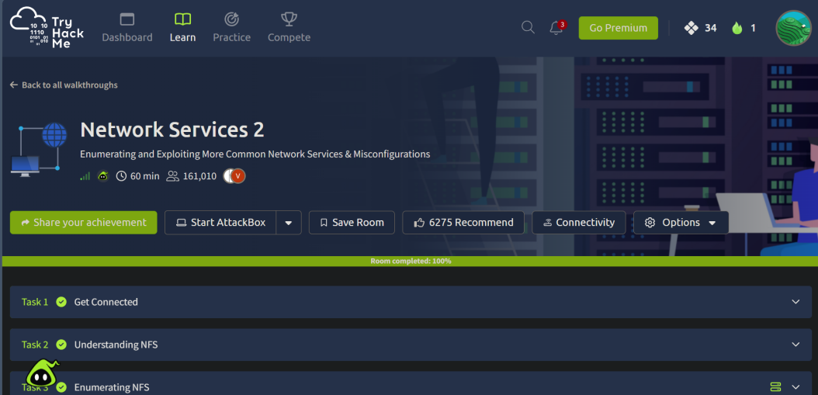
Figure 24 — TryHackMe — Network Services 2 room, 100% completed.
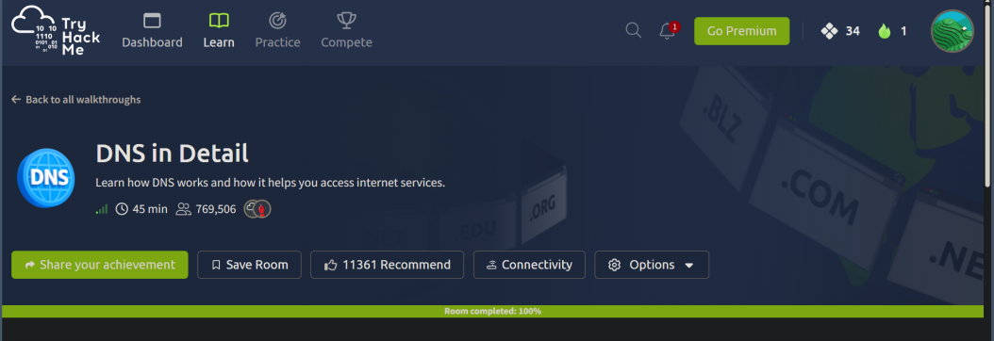
Figure 25 — TryHackMe — DNS in Detail room, 100% completed.
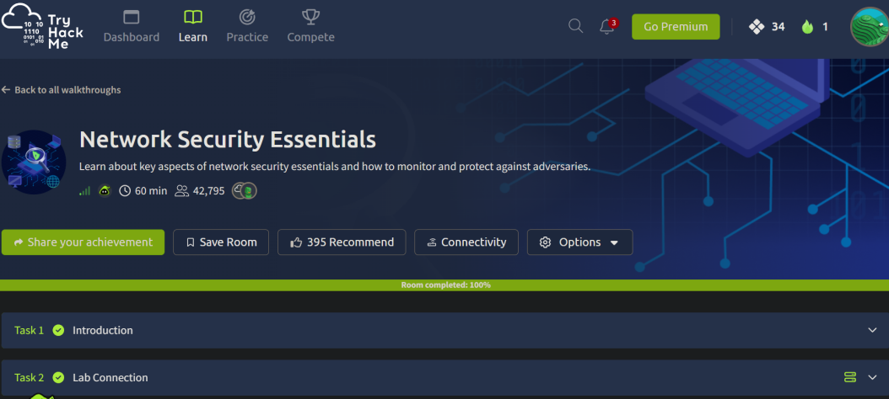
Figure 26 — TryHackMe — Network Security Essentials room, 100% completed.
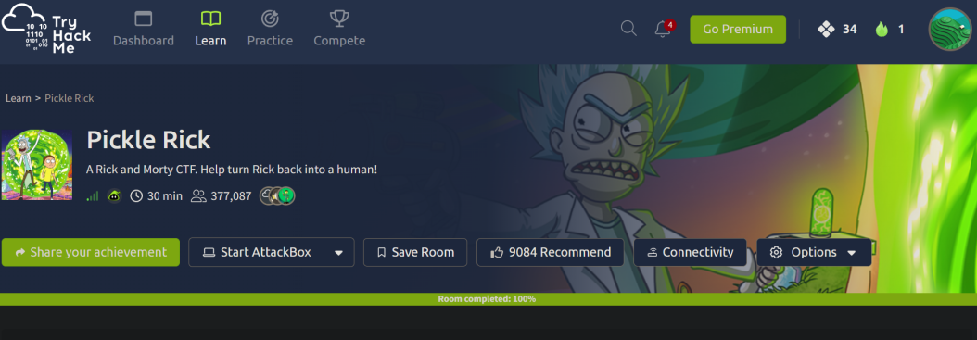
Figure 27 — TryHackMe — Pickle Rick room, 100% completed.

Featured CTF Walkthrough — Pickle Rick
Objective: exploit a web server to retrieve three hidden "ingredients" (flags) needed to turn Rick back into a human — found: "mr. meeseek hair", "1 jerry tear" (located in /home/rick/), and "fleeb juice".
Reconnaissance: enumerated the web application and its page source, discovering the hidden endpoints login.php, portal.php, and robots.txt. The robots.txt file (normally used to hide paths from search engines) contained the string "Wubbalubbadubdub", which combined with the username R1ckRul3s successfully authenticated to the portal.php login page.
Services identified: an Apache/PHP web server hosting the application; once authenticated, the portal exposed a web-based command panel that effectively functioned as a web shell, accepting and executing underlying Linux terminal commands.
What I learned: the standard cat command was blocked by the panel, requiring alternative commands such as tac, less, strings, and grep to read the ingredient files (e.g. tac Sup3rS3cretPickl3Ingred.txt). Filenames containing spaces required escaping with a backslash or quotes (e.g. tac /home/rick/second\ ingredients).
Relevant networking concepts: understanding standard HTTP/HTTPS behavior was essential to enumerate hidden directories and understand how the server processed input through the command panel; the challenge also illustrated the severe risk of misconfigured web services that allow remote command execution (RCE), directly reinforcing the network security concepts explored throughout the other TryHackMe rooms.

10. Questions

Traceroute & Path Selection
Q: Why does the packet travel PC1 → R1 → R2 → R3 → PC3 instead of going directly from PC1 to PC3?
A: PC1 and PC3 sit on completely different subnets (192.168.10.0/24 and 192.168.30.0/24). Switches operate at Layer 2 and can only forward frames within the same local broadcast domain, so PC1 must send the packet to its default gateway (R1). Each router then consults its routing table to determine the best next hop, forwarding the packet hop-by-hop (R1 → R2 → R3) until it reaches the router directly connected to the destination network.

ARP Investigation
Q: Why does PC1 generate an ARP request?
A: PC1 knows 192.168.30.10 is on a different subnet, so it must send the packet to its default gateway. It generates an ARP request to learn the MAC address of that gateway (R1) in order to build the Layer 2 Ethernet frame.
Q: Who receives the ARP request?
A: Because an ARP request is a Layer 2 broadcast (FF:FF:FF:FF:FF:FF), every device on LAN 1 receives it, but only R1 processes it and sends an ARP reply.
Q: Does the original Ethernet frame travel across all three LANs?
A: No — Ethernet frames are strictly local and do not cross router boundaries.
Q: What happens to the Layer 2 frame when the packet reaches a router?
A: The router strips the incoming Ethernet frame entirely, inspects the Layer 3 IP header to make a routing decision, then encapsulates the packet inside a brand-new Layer 2 frame for the next hop.
Q: Does the destination PC's MAC address appear in the original PC1 Ethernet frame?
A: No. The destination MAC address in PC1's original frame belongs to R1, its default gateway — not to PC3.

ICMP Investigation
Q: What is the source IP of the Echo Request?
A: 192.168.10.10 (PC1).
Q: What is the destination IP?
A: 192.168.30.10 (PC3).
Q: Does the IP source/destination change at every router?
A: No. The logical source and destination IP addresses remain constant end-to-end across all three hops.
Q: What happens to the Layer 2 MAC addresses at each router hop?
A: They are rewritten at every hop. At PC3, the inbound frame's source MAC belongs to R3's interface and the destination MAC belongs to PC3; on the outbound reply, PC3 flips the two.
Q: What happens to TTL as the packet passes through routers?
A: The Time To Live (TTL) value decreases by 1 at every router hop, preventing packets from looping endlessly if a routing misconfiguration exists.
Q: Why can a router forward the packet even though the destination is on a different network?
A: Because static routes were configured on each router. The routing table provides explicit instructions on which interface/next-hop to use to reach 192.168.30.0/24.

Security Analysis
Q: Observation 1 — ARP: what is the security risk?
A: ARP maps a known IP to an unknown MAC on the local network but has no built-in authentication. This makes it vulnerable to ARP spoofing/poisoning, where an attacker sends forged replies associating their MAC with a trusted IP (like the gateway), enabling a Man-in-the-Middle attack.
Q: Observation 2 — ICMP: what is the security risk?
A: ICMP is essential for troubleshooting (ping, traceroute), but excessive ICMP traffic can indicate a Denial of Service attack (ICMP flood), network-mapping reconnaissance, or covert data exfiltration via ICMP tunneling.
Q: Observation 3 — MAC addresses: what is their role and limitation?
A: MAC addresses are used strictly for local (Layer 2) delivery. When a packet crosses a router, the router strips the old Ethernet frame and builds a new one with fresh source/destination MACs for the next local segment.
Q: Observation 4 — Ports: why do they matter to a security analyst?
A: Source and destination ports operate at Layer 4 and direct traffic to specific applications/services (e.g. port 80 for HTTP, 22 for SSH). Monitoring them helps confirm only authorized services are running; unexpected destination ports can reveal malware talking to a command-and-control server.
Q: Observation 5 — Routing: what happens if a route is missing?
A: If R2 lacked a route to 192.168.30.0/24, it would not know where to forward the packet, would drop it, and would send an ICMP "Destination Network Unreachable" message back to the source.
Q: Identify two security concerns related to the network traffic observed in this lab.
A: First, the lack of authentication in ARP requests and replies. Second, the potential for ICMP traffic to be weaponized for network mapping or flooding.
Q: Explain one potential attack involving ARP.
A: In an ARP spoofing attack, an attacker sends forged ARP replies to a target, tricking its device into associating the attacker's MAC address with the IP address of the default gateway. The attacker can then intercept all of the target's outgoing traffic.
Q: Explain why network traffic analysis is useful for incident detection.
A: It provides ground-truth visibility into exactly what data is moving across the network. Attackers can hide malware on a host, but they cannot hide the network packets required to exfiltrate data or communicate externally.
Q: Explain how understanding normal network traffic helps identify abnormal traffic.
A: By establishing a baseline of standard behavior — knowing what normal ARP, ICMP, and port traffic looks like on a given network — an analyst can quickly spot deviations, such as unusual port usage or excessive ICMP requests, that indicate a potential breach.

Core Networking Concepts
Q: What is ARP?
A: The Address Resolution Protocol (ARP) translates a known Layer 3 IP address into an unknown Layer 2 MAC address on a local network.
Q: What is ICMP?
A: The Internet Control Message Protocol (ICMP) is used by network devices to send error messages and operational information, such as confirming whether a destination is reachable (as with ping).

Q: What is TTL?
A: Time to Live (TTL) is a value in an IP packet that limits its lifespan. Every router hop decrements it by one; if it reaches zero, the packet is discarded, preventing infinite loops.
Q: What happens to Ethernet frames when they cross a router?
A: The router strips the incoming frame, makes a routing decision based on the IP packet inside, and encapsulates it in a brand-new Ethernet frame with the source/destination MAC addresses required for the next hop.
Q: Why does the IP source/destination remain end-to-end while MAC addresses are hop-by-hop?
A: IP addresses identify the ultimate origin and final destination of data across the entire path. MAC addresses are only used for physical delivery on the immediate local segment, so new MACs are needed for each physical jump while the destination IP stays unchanged.
Q: What information can a security analyst obtain from source/destination ports?
A: Ports reveal which specific application or service the traffic is intended for (e.g. web traffic, SSH, DNS), helping identify unauthorized services, command-and-control communications, or malware.
Q: What was the most interesting packet observed and why?
A: The ICMP "Destination Net Unreachable" packet seen during the troubleshooting step was the most interesting — it clearly demonstrated how a router communicates a forwarding failure back to the source when a routing table entry is missing.
Q: What is the difference between a switch and a router?
A: A switch operates at Layer 2 (Data Link) and forwards frames between devices on the same local network using MAC addresses. A router operates at Layer 3 (Network) and forwards packets between different networks using IP addresses.
Q: Why does every PC require a default gateway to communicate with another network?
A: If a destination IP is outside a PC's local subnet, the PC cannot reach it directly. The default gateway is the designated exit point — a router that takes the local packet and forwards it toward the outside network.
Q: What is a subnet mask?
A: A subnet mask separates an IP address into a network portion and a host portion, telling devices which IPs belong to their local network and which require routing.
Q: Why were /30 networks used between the routers?
A: A /30 subnet mask provides exactly two usable host addresses — ideal for a point-to-point connection between two routers, since it avoids wasting IP addresses that would go unused in a larger subnet.
Q: What is the purpose of a routing table?
A: A routing table is a set of rules maintained by a router that dictates where traffic should be sent, mapping destination networks to the outbound interface or next-hop IP needed to reach them.
Q: What is a static route?
A: A static route is a path manually entered into a router's routing table by a network administrator, instructing it exactly how to reach a specific destination network.
Q: What are the advantages and disadvantages of static routing?
A: Advantages: very little CPU/bandwidth overhead, highly secure since no routing information is advertised, and predictable routing paths. Disadvantages: it does not automatically scale as a network grows, and it cannot automatically reroute traffic if a link fails.

11. Reflection
This week's assignment provided a foundational understanding of how network traffic physically and logically moves between devices. I learned how to configure a three-router enterprise network using Cisco Packet Tracer, correctly apply /30 and /24 subnet masks, and implement static routing to ensure end-to-end connectivity.
The most difficult part of the lab was troubleshooting a connectivity issue where my initial pings failed. I realized I had physically cabled the wrong gigabit interfaces on Routers 2 and 3, which taught me the importance of verifying Layer 1 connections before jumping into complex CLI troubleshooting.
During the packet analysis phase, I was surprised to see visually in Simulation Mode how the router strips the Layer 2 Ethernet frame and rewrites the source and destination MAC addresses at every hop, while the Layer 3 IP addresses remain constant from the source to the final destination.
This networking knowledge is directly tied to cybersecurity. To effectively defend a network, it is essential to establish a baseline of normal behavior. I cannot identify anomalous traffic — such as an ARP spoofing attack or an ICMP flood — without first understanding how these protocols are supposed to behave natively. Moving forward, I plan to investigate live traffic capture using Wireshark on my own network to practice identifying these protocols and analyzing raw packets in a real-world environment.

Final Submission Checklist
☑ Three-router topology is complete.
☑ All interfaces are configured.
☑ PC IP addresses are configured.
☑ Static routes are configured.
☑ All three LANs communicate successfully.
☑ Routing tables have been verified.
☑ Traceroute has been performed.
☑ ARP traffic has been analyzed.
☑ ICMP traffic has been analyzed.
☑ TCP/UDP traffic has been investigated.
☑ One network failure was intentionally introduced and fixed.
☑ All required online labs are completed.
☑ Required screenshots are included.
☑ Assessment questions are answered.
☑ PDF report has been checked for readability.

